ADAC Brake Test: ATE Ceramic Takes First Place
- ATE Ceramic ranks highest in a comparison with five other brake systems
- Outstanding safety and durability: top score for wear resistance, second-best rating for braking distance
Schwalbach, Germany, July 2021. In a prestigious brake test conducted by Germany’s largest automobile club, ADAC, ATE Ceramic brake pads have taken first place in a comparison with five other brands, winning an overall rating of 1.7 (good). The tests covered a total of six different brake pads and disks, including one OE product, several brand-name brakes and sports brakes, and a budget brake. In combination with Original ATE brake disks, ATE Ceramic brake pads scored well above their competitors in terms of wear. In a test under realistic conditions with heavy braking loads, they achieved an overall rating of 1.0 – more than a full point above the nearest competitor. In the braking distance test they placed second (1.5) and had good friction characteristics. ATE is a brand of the technology company and automotive supplier Continental.
“ATE Ceramic brake pads offer two key advantages: a high degree of safety, as shown by the brake test results, and durability,” says Continental product manager Maik Spengel. “Thanks to their special pad formula they have very low abrasion, which means they generate less brake dust. This not only reduces wear, it benefits the environment – and it ensures satisfied customers for workshops.”
“We’re especially happy that the ADAC has confirmed the outstanding characteristics of ATE Ceramic brake pads, following the innovation prize 10 years ago at the tire industry trade fair in Essen,” adds Peter Wagner, head of the OE & Aftermarket Services segment at Continental. “The test results show that ATE brake pads are equal to OE products in every way.”
The complete ADAC test report is available (in German) at www.adac.de.

Continental develops pioneering technologies and services for sustainable and connected mobility of people and their goods. Founded in 1871, the technology company offers safe, efficient, intelligent and affordable solutions for vehicles, machines, traffic and transportation. Continental generated preliminary sales of €37.7 billion in 2020 and currently employs around 235,000 people in 58 countries and markets. In 2021, the company celebrates its 150th anniversary.
Drawing on more than 120 years of cooperation with vehicle manufacturers, Continental offers a broad range of spare parts in OEM quality for the aftermarket. Under brands like Continental, Uniroyal, Semperit, ATE and GALFER, the technology company manufactures tens of thousands of products, including tires, brakes, drive components and thermal management components. It also provides diagnostic solutions, tools and services for repair shops. Continental is one of the most important suppliers in the independent automotive aftermarket.
Press contact

Christopher Schrecke
Head of Media Relations
Commercial Vehicles & Services
Continental Aftermarket & Services GmbH
Phone: +49 6196 87 1605
Email: christopher.schrecke@continental-corporation.com

Press portal: www.continental-press.com
Media center: www.continental.com/media-center

pictures/captions
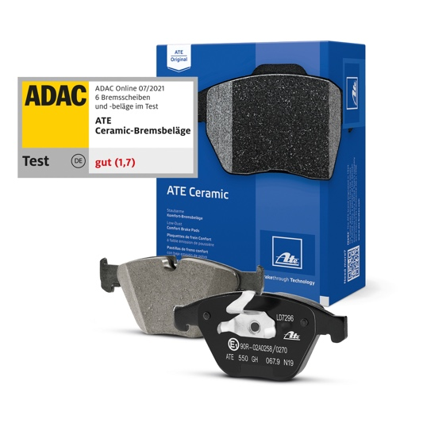  Continental_PP_ATE Ceramic ADAC1 | ATE Ceramic brake pads took first place in the ADAC brake test with an overall rating of 1.7.
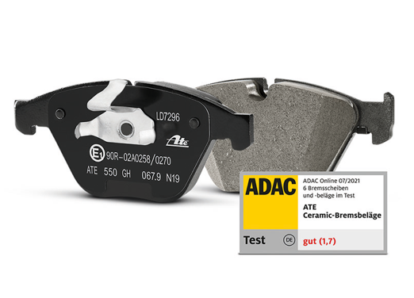  Continental_PP_ATE Ceramic ADAC2 | Low wear: The special ATE Ceramic pad formula reduces brake dust, and that also benefits the environment.
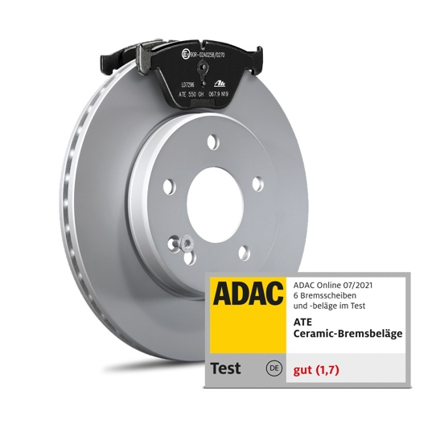  Continental_PP_ATE Ceramic ADAC3 | Convincing: ATE Ceramic brake pads stand out from the competition with an excellent coefficient of friction and minimal wear.

